PIZZA SALES SQL QUERIES

A.KPI’s

- Total Revenue:

SELECT SUM(total_price) AS Total_Revenue
FROM pizza_sales;

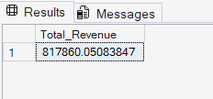

- Average Order Value

SELECT SUM(total_price) / COUNT(DISTINCT order_id)
AS Avg_Order_Value
FROM pizza_sales;

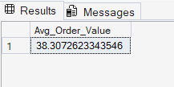

- Total Pizzas Sold:

SELECT SUM(quantity) AS Total_Pizza_Sold
FROM pizza_sales;

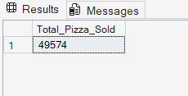

- Total Orders:

SELECT COUNT(DISTINCT order_id) AS Total_Orders
FROM pizza_sales
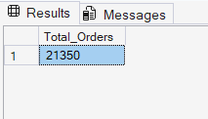

- Average Pizzas Per Order:

SELECT CAST(SUM(quantity) AS DECIMAL(10,2)) /
CAST(COUNT(DISTINCT order_id) AS DECIMAL(10,2))
AS Avg_pizzas_per_order
FROM pizza_sales
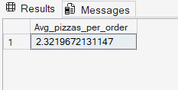

B. CHARTS REQUIREMENTS:

- Daily Trend for Total Orders:

--Daily Trend
SELECT DATENAME(DW, order_date) AS Order_day,
COUNT(DISTINCT order_id) AS Total_orders
FROM pizza_sales
GROUP BY DATENAME(DW, order_date);

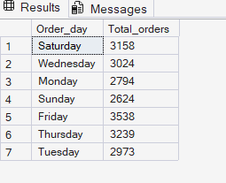

- Hourly Trend for Total Orders

--Hourly Trend
SELECT DATEPART(HOUR,order_time) AS order_hours,
COUNT(DISTINCT order_id) AS Total_orders
FROM pizza_sales
GROUP BY DATEPART(HOUR,order_time)
ORDER BY DATEPART(HOUR,order_time);

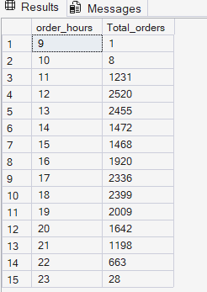

- Percentage of Sales by Pizza Category:

SELECT pizza_category, SUM(total_price) * 100 / (SELECT SUM(total_price) from pizza_sales) AS Pct_sales
FROM pizza_sales
GROUP BY pizza_category

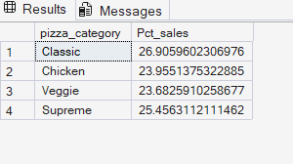

- Percentage of Sales by Pizza Size:

--Percentage Sales by Size
SELECT pizza_size, SUM(total_price) AS Total_sales,CAST(SUM(total_price) * 100 / (SELECT SUM(total_price) from pizza_sales) AS DECIMAL(10,2)) AS Pct_sales
FROM pizza_sales
GROUP BY pizza_size
ORDER BY Pct_sales DESC;

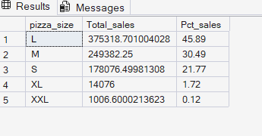

- Total Pizzas Sold By Pizza Category:

--Total Pizzas sold by Category
SELECT pizza_category,SUM(quantity) AS Total_Pizzas_Sold
FROM pizza_sales
GROUP BY pizza_category;

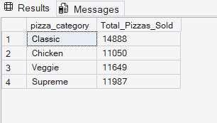

- Top 5 Best Sellers by Total Pizzas Sold:

--Top 5 Best Sellers by Total sold
SELECT TOP 5 pizza_name, SUM(quantity) AS Total_pizzas_Sold
FROM pizza_sales
GROUP BY pizza_name
ORDER BY Total_pizzas_Sold DESC

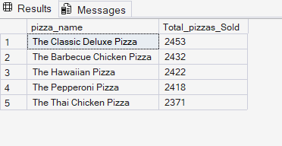

- Bottom 5 Worst Sellers by Total Pizzas Sold:

SELECT TOP 5 pizza_name, SUM(quantity) AS Total_pizzas_Sold
FROM pizza_sales
GROUP BY pizza_name
ORDER BY Total_pizzas_Sold ASC

